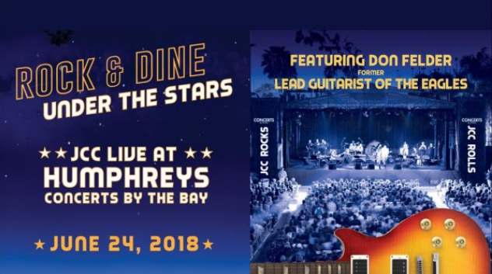
FOR IMMEDIATE RELEASE
Contact Jodi Rudick, Publicity and Promotions Manager
jodir@lfjcc.org • Office: 858-362-1351• Cell: 760-809-3231
High Resolution Photos: www.lfjcc.org/pressroom
Rock and Dine Under the Stars with Former Eagles Lead Guitarist Don Felder
on June 24 to Support Community Programs at the JCC
San Diego -- Rock & Dine Under The Stars at Humphreys Concerts by the bay with an exclusive, private concert by Don Felder, former lead guitarist of the Eagles, to support programs and services at the Lawrence Family Jewish Community Center, JACOBS FAMILY CAMPUS. The event will take place on June 24 beginning at 6:00 PM with cocktails and dinner, followed by the concert and a decadent dessert reception.
“Patron Party is the JCC’s largest fundraiser of the year,” explains Betzy Lynch, CEO of the Lawrence Family JCC. “Money raised at this event is used to help fund scholarships for families in need, giving them access to the JCC’s wide variety of programs ranging from preschool to senior services and everything in between. For example,” Lynch continues, “hundreds of San Diego working parents rely on the JCC for age-appropriate enrichment activities for their children during non-school hours and in summer and holiday camps: afterschool programs; as well as sports, fitness and other extracurricular activities. Many local families, including those with special needs children, depend on scholarships to offset fees and tuition. The generosity of our donors at Patron Party increases participation and inclusivity for families across the county.”
“The Eagles are on everyone’s playlist; Don Felder was the perfect choice to headline this year’s Patron Party that combines classic rock music, a beautiful setting, a sumptuous dinner, and a lively crowd,” adds Lynch. In his video, Live at Hotel California, Felder, who along with his Eagles bandmates was inducted into the Rock & Roll Hall of Fame in 1998 says, “I’ve played some of the largest stadiums and arenas in the world. But honestly, I prefer to play smaller, more intimate venues. It’s a much better experience for both the artist and the audience when they can get so close that they can reach out and through the songs they’ve heard on the radio for years.”
The Patron Party committee, spearheaded by co-chairs Susan and Jim Morris, created giving levels in keeping with iconic Eagles’ song titles such as “The Best of My Love,” “Life in the Fast Lane,” “Tequila Sunrise,” and the top tier, “Take It To The Limit,” which includes two tables, front row/center stage seating, a specialty food experience and champagne, invitations to a VIP meet-and-greet reception with Don Felder, and valet parking. All tickets and sponsorship levels, which start at $360, provide signature cocktails, patron dinner, Don Felder concert, and gourmet dessert reception.
Event Details:
When: Sunday, June 24, 2018, 6 PM to 10 PM
Where: Humphreys Concerts by the bay, 2241 Shelter Island Drive, San Diego, 92106
Tickets begin at $360
Event website: www.lfjcc.org/patronparty
For more information: Paige Pick, Director of Development, at 858-362-1355 or email paigep@lfjcc.org to reserve your seat

###

Don Felder Press Photos
High Resolution Photos at: www.lfjcc.org/pressroom
Photo Credit: Michael Helms
